Lab 5.6.2: Challenge RIP Configuration

Topology Diagram
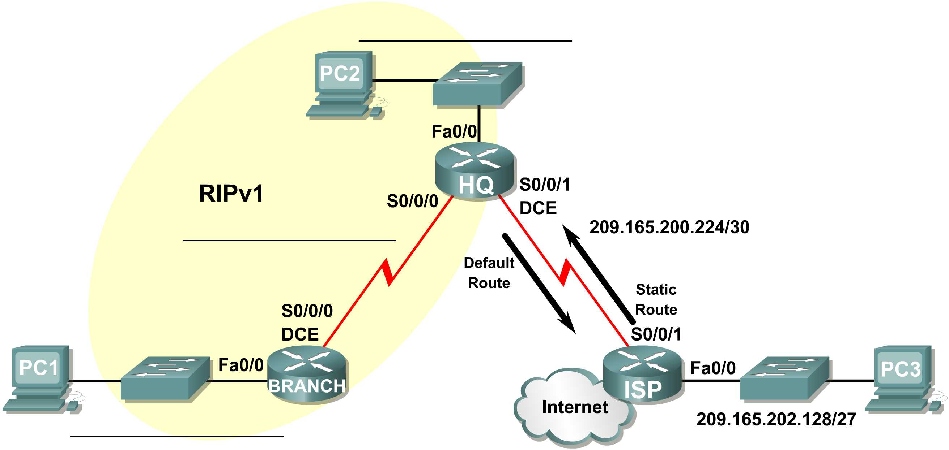

Addressing Table
Device | Interface | IP Address | Subnet Mask | Default Gateway
BRANCH | Fa0/0 | 10.10.2.1 | 255.255.254.0 | N/A
BRANCH | S0/0/0 | 192.168.1.126 | 255.255.255.128 | N/A
HQ | Fa0/0 | 192.168.1.129 | 255.255.255.128 | N/A
HQ | S0/0/0 | 192.168.1.1 | 255.255.255.128 | N/A
HQ | S0/0/1 | 209.165.200.226 | 255.255.255.252 | N/A
ISP | Fa0/0 | 209.165.202.129 | 255.255.255.224 | N/A
ISP | S0/0/1 | 209.165.200.225 | 255.255.255.252 | N/A
PC1 | NIC | 10.10.3.254 | 255.255.254.0 | 10.10.2.1
PC2 | NIC | 192.168.1.254 | 255.255.255.128 | 192.168.1.129
PC3 | NIC | 209.165.202.158 | 255.255.255.224 | 209.165.202.129

Task 1: Subnet the Address Space.
Step 1: Examine the network requirements.
The addressing for the network has the following requirements:
- The ISP LAN will use the 209.165.202.128/27 network.
- The link between the ISP router and the HQ router will use the 209.165.200.224/30 network.
- The 192.168.1.0/24 network must be subnetted for use in the HQ LAN and the link between the HQ and BRANCH routers. The HQ LAN will require 50 host IP addresses.
- The BRANCH LAN will use the 10.10.2.0/23 network.
(Note: Remember that the interfaces of network devices are also host IP addresses and are included in the above addressing requirements.)
Step 2: Consider the following questions when creating your network design:
How many subnets need to be created from the 192.168.1.0/24 network? 2
What is the subnet mask for this network in dotted decimal format? 255.255.255.128
What is the subnet mask for the network in slash format? /25
What are the network addresses of the subnets?
Subnet 1: 192.168.1.0 /25
Subnet 2: 192.168.1.128 /25
How many usable host IP addresses are there per subnet? 128
How many usable hosts IP addresses are available in the BRANCH LAN? 512
Task 7: Configure RIP Routing on the BRANCH Router.
Consider the networks that need to be included in the RIP updates that are sent out by the BRANCH router.
What networks are currently present in the BRANCH routing table before RIP is configured? List the networks with slash notation.
- 10.1.0.0 /23 (Network)
- 192.168.1.0 /25 (Serial 0/0/0)

What commands are required to enable RIP version 1 and include these networks in the routing updates?
- Router rip
- Network 10.0.0.0
- Network 192.168.1.0

Are there any router interfaces that do not need to have RIP updates sent out? yes

What command is used to disable RIP updates on this interface?
Passive-interface FastEthernet 0/0
Task 8: Configure RIP and Static Routing on the HQ Router
Consider the type of static routing that is needed on HQ.
What networks are present in the HQ routing table? List the networks with slash notation.
- 192.168.1.0/25 (Serial 0/0/0)
- 209.165.200.0/27 (Network)
A static default route will need to be configured to send all packets with destination addresses that are not in the routing table to the ISP router. What command is needed to accomplish this? Use the appropriate exit interface on the HQ router in the command.
- Ip route 0.0.0.0 0.0.0.0 serial 0/0/1
What commands are required to enable RIPv1 and include the LAN network in the routing updates?
- router rip
- network 192.168.1.0
Are there any router interfaces that do not need to have RIP updates sent out? yes
What command is used to disable RIP updates on this interface?
- passive-interface FastEthernet0/0
The HQ router needs to send the default route information to the BRANCH router in the RIP updates. What command is used to configure this?

- default-information originate
Task 9: Configure Static Routing on the ISP Router
Static routes will need to be configured on the ISP router for all traffic that is destined for the RFC 1918 addresses that are used on the BRANCH LAN, HQ LAN, and the link between the BRANCH and HQ routers.
What are the commands that will need to be configured on the ISP router to accomplish this?
ISP(config)# ip route 10.10.2.0 255.255.254.0 Serial0/0/1
ISP(config)# ip route 192.168.1.0 255.255.255.0 Serial0/0/1
Task 10: Verify the Configurations
Answer the following questions to verify that the network is operating as expected.
From PC2, is it possible to ping PC1? yes
From PC2, is it possible to ping PC3? yes
From PC1, is it possible to ping PC3? yes

The answer to the above questions should be yes. If any of the above pings failed, check your physical connections and configurations. Refer to the basic troubleshooting techniques used in the Chapter 1 labs.
What routes are present in the routing table of the BRANCH router?
- 10.0.0.0/23
- 192.168.1.0/25
- 0.0.0.0/0
What is the gateway of last resort in the routing table of the BRANCH router?
____________________________________________________________________________
What routes are present in the routing table of the HQ router?
- 10.0.0.0/8
- 192.168.1.0/25
- 209.165.200.0/27
- 0.0.0.0/0
What networks are present in the routing table of the ISP router?
- 10.0.0.0/23
- 192.168.1.0/24
- 209.165.200.0/27
- 209.165.202.0/27
What networks, including the metric, are present in the RIP updates sent from the HQ router?
____________________________________________________________________________
____________________________________________________________________________
What networks, including the metric, are present in the RIP updates sent from the BRANCH router?
____________________________________________________________________________
____________________________________________________________________________
Task 11: Reflection
If static routing were used instead of RIP on the BRANCH router, how many individual static routes would be needed for hosts on the BRANCH LAN to communicate with all of the networks in the Topology Diagram? Three

